6.RP.1 Understand the concept of a ratio and use ratio language to describe a ratio relationship between two quantities.

A ratio is the comparison of two quantities or measures. The comparison can be part-to-whole (ratio of guppies to all fish in an aquarium) or part-to-part (ratio of guppies to goldfish).
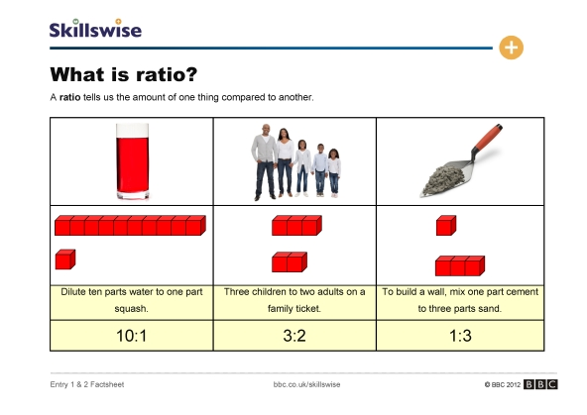
3 WAYS TO WRITE RATIOS
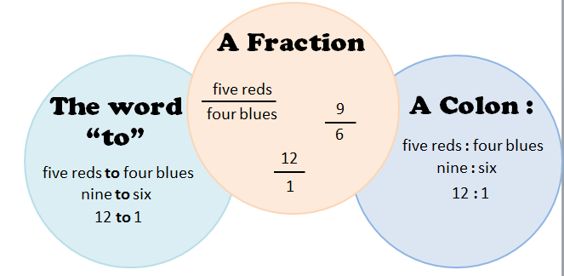
Students should be able to identify and describe any ratio using “For every _____ ,there are _____,” using knowledge of equivalent ratios.
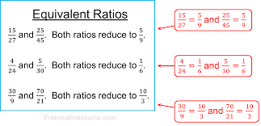
Student Notes:
The ratio of wings to beaks in the bird house at the zoo was 2:1, because for every 2 wings there was 1 beak.
For every vote candidate A received, candidate C received nearly three votes.

6.RP.2 Understand the concept of a unit rate a/b associated with a ratio a:b with b ≠ 0, a context of a ratio relationship.

A unit rate expresses a ratio as part-to-one, comparing a quantity in terms of one unit of another quantity. Common unit rates are cost per item or distance per time.
In 6th grade, students are not expected to work with unit rates expressed as complex fractions. Both the numerator and denominator of the original ratio will be whole numbers.
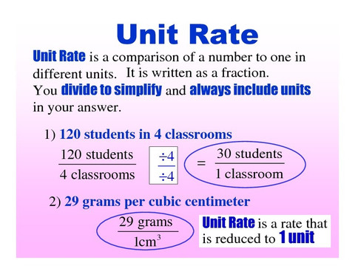
6.RP.3 Use ratio and rate reasoning to solve real-world and mathematical problems, e.g., by reasoning about tables of equivalent ratios, tape diagrams, double number line diagrams, or equations.

Ratio Table
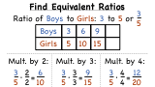
Student Notes:
Example 1: There are 2 cookies for 3 students. What is the amount of cookie each student would receive? (i.e. the unit rate)

Example 2: On a bicycle Jack can travel 20 miles in 4 hours. What are the unit rates in this situation, (the distance Jack can travel in 1 hour and the amount of time required to travel 1 mile)?

Tape Diagram
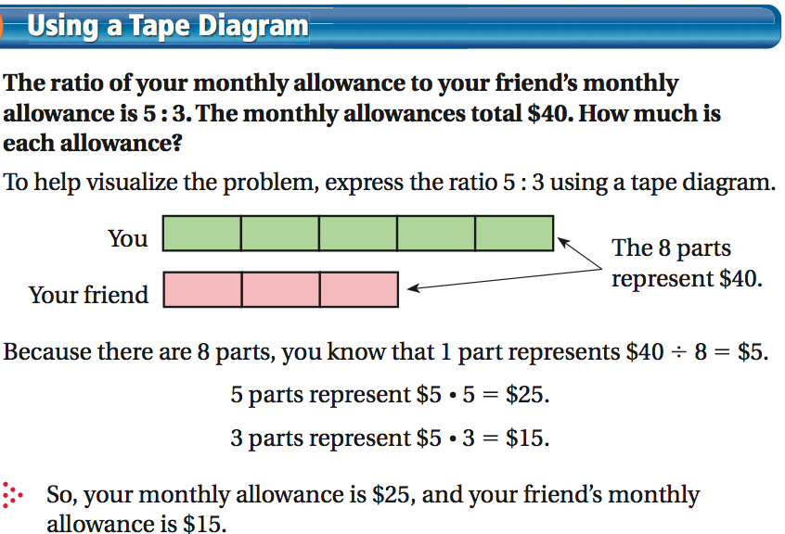

Double Number Line
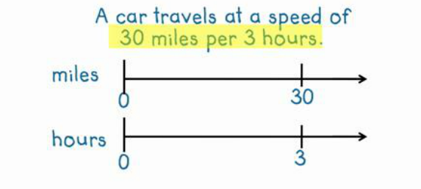

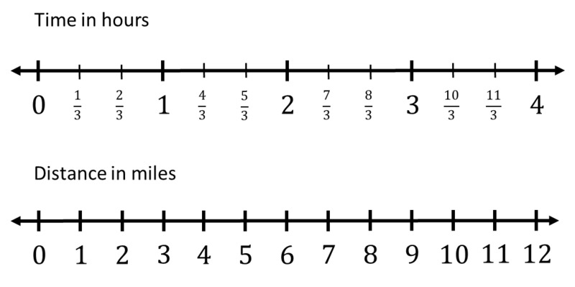

Student Notes:

3a. Make tables of equivalent ratios relating quantities with whole number measurements, find missing values in the tables, and plot the pairs of values on the coordinate plane. Use tables to compare ratios.

Example 1: At Books Unlimited, 3 paperback books cost $18. What would 7 books cost? How many books could be purchased with $54.
Solution: To find the price of 1 book, divide $18 by 3. One book costs $6. To find the price of 7 books, multiply $6 (the cost of one book times 7 to get $42. To find the number of books that can be purchased with $54, multiply $6 times 9 to get $54 and then multiply 1 book times 9 to get 9 books.
Books (n) | Cost (c)
1 | 6
3 | 18
5 | 30
7 | 42
9 | 54
Students use tables to compare ratios. Another bookstore offers paperback books at the prices below. Which bookstore has the best buy? Explain your answer.
Books (n) | Cost (c)
1 | 5
3 | 15
5 | 25
7 | 35
9 | 45
To help understand the multiplicative relationship between the number of books and cost, students write equations to express the cost of any number of books. Writing equations is foundational for work in 7th grade. For example, the equation for the first table would be C = 6n, while the equation for the second bookstore is C = 5n. The numbers in the table can be expressed as ordered pairs (number of books, cost) and plotted on a coordinate plane.

Student Notes:

Example 2: Ratios can also be used in problem solving by thinking about the total amount for each ratio unit. The ratio of cups of orange juice concentrate to cups of water in punch is 1: 3. If James made 32 cups of punch, how many cups of orange did he need?
Solution: Students recognize that the total ratio would produce 4 cups of punch. To get 32 cups, the ratio would need to be duplicated 8 times, resulting in 8 cups of orange juice concentrate

Example 3: Using the information in the table, find the number of yards in 24 feet.
Feet | 3 | 6 | 9 | 12 | 15 | 24
Yards | 1 | 2 | 3 | 4 | 5 | ?

Solution:
There are several strategies that students could use to determine the solution to this problem:
- Add quantities from the table to total 24 feet (9 feet and 15 feet); therefore the number of yards in 24 feet must be 8 yards (3 yards and 5 yards).
- Use multiplication to find 24 feet: 1) 3 feet x 8 = 24 feet; therefore 1 yard x 8 = 8 yards, or 2) 6 feet x 4 = 24 feet; therefore 2 yards x 4 = 8 yards

3b. Solve unit rate problems including those involving unit pricing and constant speed.

Example: In trail mix, the ratio of cups of peanuts to cups of chocolate candies is 3 to 2. How many cups of chocolate candies would be needed for 9 cups of peanuts?
Peanuts | Chocolate
3 | 2
6 | 4
9 | 6

Solution: One possible solution is for students to find the number of cups of chocolate candies for 1 cup of peanuts by dividing both sides of the table by 3, giving 2/3 cup of chocolate for each cup of peanuts. To find the amount of chocolate needed for 9 cups of peanuts, students multiply the unit rate by nine (9 •2/3), giving 6 cups of chocolate.

Question 1: If it took 7 hours to mow 4 lawns, then at that rate, how many lawns could be mowed in 35 hours? At what rate were lawns being mowed?

Question 2: If steak costs $2.25 per pound, how much does 0.8 pounds of steak cost? Explain how you determined your answer.

3c. Find a percent of a quantity as a rate per 100 (e.g., 30% of a quantity means 30/100 times the quantity); solve problems involving finding the whole, given a part and the percent.

Example 1: What percent is 12 out of 25?
Part | Whole
12 | 25
24 | 50
48 | 100

Solution: One possible solution method is to set up a ratio table: Multiply 25 by 4 to get 100. Multiplying 12 by 4 will give 48, meaning that 12 out of 25 is equivalent to 48 out of 100 or 48%.

Example 2: What is 40% of 30?
Solution: There are several methods to solve this problem. One possible solution using rates is to use a 10 x 10 grid to represent the whole amount (or 30). If the 30 is divided into 100 parts, the rate for one block is 0.3. Forty percent would be 40 of the blocks, or 40 x 0.3, which equals 12.
3d. Use ratio reasoning to convert measurement units; manipulate and transform units appropriately when multiplying or dividing quantities.

A ratio can be used to compare measures of two different types, such as inches per foot, milliliters per liter and centimeters per inch. Students recognize that a conversion factor is a fraction equal to 1 since the numerator and denominator describe the same quantity. For example, 12 inches/1 foot is a conversion factor since the numerator and denominator equal the same amount. Since the ratio is equivalent to 1, the identity property of multiplication allows an amount to be multiplied by the ratio. Also, the value of the ratio can also be expressed as 1 foot/12 inches allowing for the conversion ratios to be expressed in a format so that units will “cancel”.
Students use ratios as conversion factors and the identity property for multiplication to convert ratio units.
Example 1: How many centimeters are in 7 feet, given that 1 inch ≈ 2.54 cm.

Student Notes:

Question: If 30% of the students in Mrs. Rutherford’s class like chocolate ice cream, then how many students are in Mrs. Rutherford’s class if 6 like chocolate ice cream?

Ratio Table

Tape Diagram

Double Number Line

