Name: ________________________ HR: ______ Date: _________________

Ratio Tables with Totals Homework

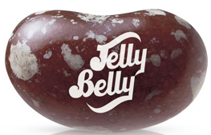
Jelly Belly Jelly Beans are gourmet jelly beans that come in many “true to life” flavors.

Many people like to make combinations of the jelly bean flavors when they eat them. Here are some ratio problems based on jelly bean recipes.

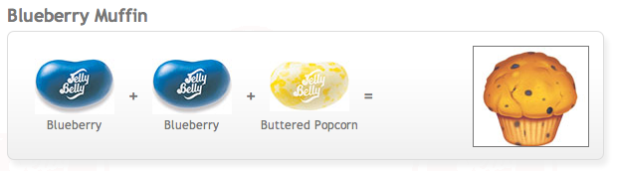
- What is the ratio of “buttered popcorn” to “blueberry”?

_______________________

- Draw a Tape Diagram tool below to show the relationship of this ratio.

- Sally is making a big handful of Blueberry Muffin flavor with her jelly beans. She has 24 jelly beans in her hand. How many are blueberry? Fill in the tape diagram you drew to answer this question.

Answer: _______________________________

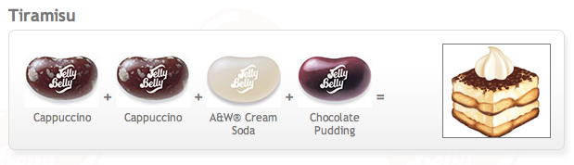
- What is the ratio of “chocolate pudding” to “cream soda” to “cappuccino”?

______________________________

- Draw a Tape Diagram tool below to show the relationship of this ratio.

- Jessie made a bowl of Tiramisu flavor with these flavors. She knows that she used 25 cream soda jelly beans. How many jelly beans are in the bowl altogether?

Answer: ___________________________

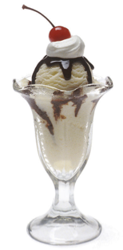
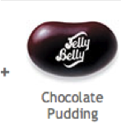
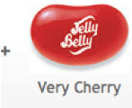
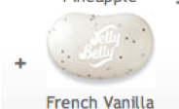
7.)
Ice Cream Sundae

- What is the ratio of “chocolate pudding” to “French vanilla” to “very cherry”?
______________________________

- Draw a Tape Diagram tool below to show the relationship of this ratio.

- Raphael bought 72 jelly beans to share with his friends and made sure that all the jelly beans together made the flavor “Ice Cream Sundae” perfectly.
  - How many French Vanilla jelly beans is that? _________________
  - How many Chocolate Pudding jelly beans is that? ______________
  - How many Very Cherry jelly beans is that? _________________

Here are some additional jelly bean flavors from the Jelly Belly Jelly Bean Company.

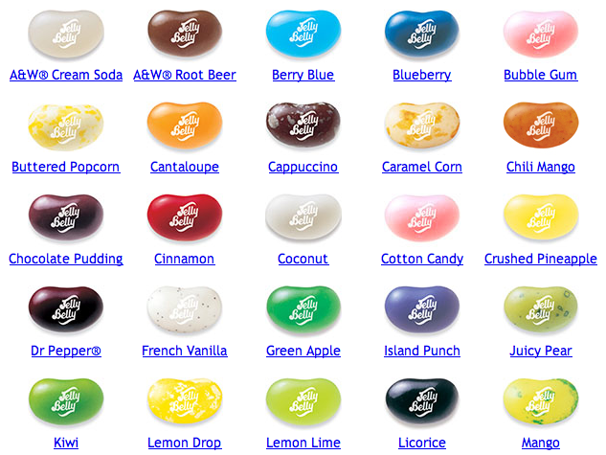

10.) Write your own recipe for a “true to life” treat. Give your recipe a name. Make sure you show or write how many jelly beans of each flavor you need.

My Recipe for _________________________________________________________________
11.) What is the ratio of jelly bean flavors in your recipe?

________________________________________________________________

________________________________________________________________

